**NEW WEBSITE FOR THE PARISH COUNCIL**

**T**he Parish Council will have a new website in due course. This is in the draft stage at the moment.

**NEW EMAIL ADDRESS FOR THE PARISH COUNCIL**

The Parish Council will also be changing the email address.

Further details will be in the next newsletter and on the Parish noticeboards.



|  |  |
| --- | --- |
|  |  |

Community Infrastructure Levy (CIL)

Funding Available

The Parish Council has received funding via Hambleton District Council (HDC), with regards to the above levy.  The CIL is a charge which local authorities (District Councils) place on most types of new development in their area.

The CIL is to be used to pay for infrastructure identified as required to support the development growth in the Parish.

The Parish Council has to account for the spending of the money, in an annual report to HDC, therefore the Parish Council will need to keep accurate records of both the applications for the funds and the spending of the levy.

**Organisations/groups in the parish, who wish to bid for funds from the levy, can apply to the Parish Council.** There is an application form to complete to request funding.

Contact details for the Parish Council are at the bottom of this newsletter.

**GRASS CUTTING**

The three-year contract for grass cutting and maintenance services 2021 – 2023 has been awarded to JCS Services.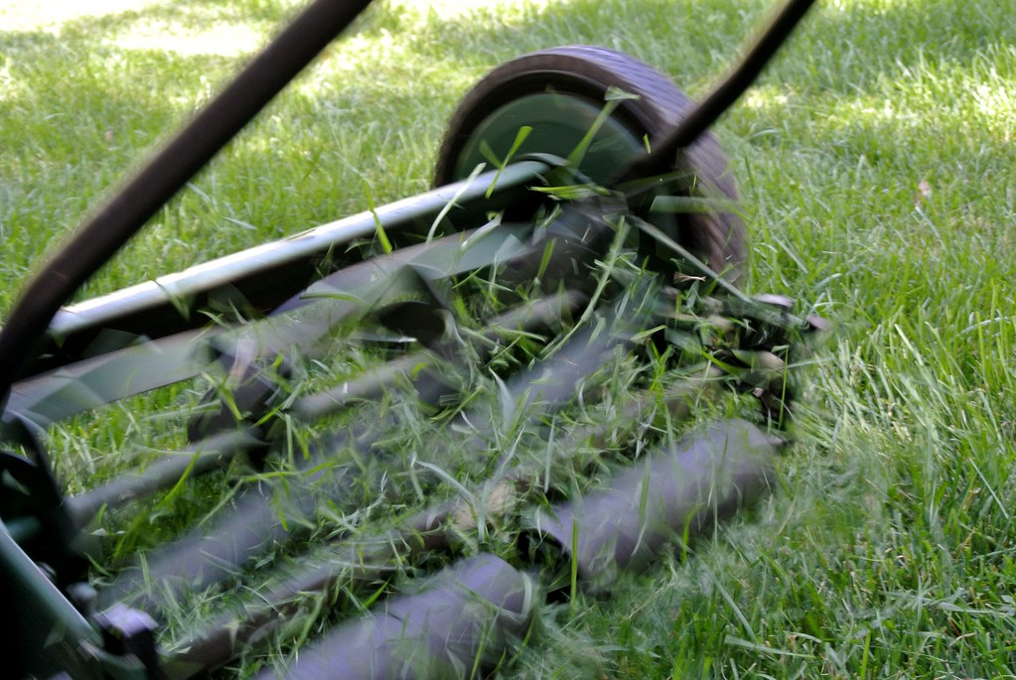

**DOG FOULING**

**Complaints have been received regarding dog fouling in the Parish.**

**This is particular unpleasant for people out walking, cutting grass and is dangerous for children out playing.**

**Please clear up after your dogs, use the bins provided.**

**NEXT PARISH COUNCIL MEETING**

The next Parish Council meeting will be held on 14th July 2021 at 7pm. Venue to be confirmed. Further details will be on the Parish noticeboards.

|  |  |
| --- | --- |
| REGENCY |  |

**The Parish Council has been meeting virtually, for over a year to consider several items of business. The Annual Parish Meeting and Annual Parish Council Meeting were held virtually this year.**

**2020/21 ACCOUNTS**

The Council’s accounts have now been audited.

The full details will be displayed online at:

www.tanfieldparishcouncil.btck.co.uk/

**ANNUAL PARISH MEETING**

Community organisations from the Parish attending the Annual Parish Meeting on 5 May, 2021, via zoom.

Representatives reported on the activities of their organisation during 2020/21. These reports will be added to the Parish Council website shortly at www.tanfieldparishcouncil.btck.co.uk

If your organisation was not included in the invites and you would like to attend in 2022, please contact the Parish Clerk. The Parish Council is interested to know what clubs/activities are taking place in the Parish.

**Clerk to the Parish Council:**

Ms Alison Carter

c/o Highfield House, Thornborough, North Yorkshire, DL8 2RH

Tel: 07762403999

E-mail: tanfieldparishcouncil@yahoo.co.uk

www.tanfieldparishcouncil.btck.co.uk